Monymusk School Reporting Calendar
Throughout the year there will be “Sharing our Learning” events where you and your child will have an extended opportunity to discuss you child’s learning journey within the school context and access to various forms of evidence.
In terms one and four, there will be an opportunity to meet with your child’s teacher to discuss all aspects of your child’s development and their next steps. If you would like to discuss your child’s progress at any point throughout the year, please contact the school to make an appointment.

Term One:
- Parent/pupil/ teacher consultations
- P1 literacy and numeracy evening.
Term Two:
- Sharing our learning event.
Term Three:
- GLEE competition.
- Sharing our learning event.
Term Four:
- Annual written progress report
- Parent/Pupil/Teacher interviews
- Sports Day
- End of year school show.

On going
- Seesaw pupil profiling
- Class and Head Teacher newsletters
- Social media (twitter)
- Community cafes
- Additional support needs planning meetings.
- Wall displays
- Celebration of wider achievements.
- School website
- Mymaths.co.uk
- Open door policy
- House challenges
- Homework as per policy.
Asking your child the right questions will help you get more information about:
- your child’s understanding of their own learning
- how they are progressing and managing their learning
What kind of questions could I ask my child?
About Activities
- What activities did you do today?
- How did you know what to do?
- What was your role in the activity?
- What/who were you working with today? How did it go?
- What equipment/tools did you need? Can you use them?
- What skills were you learning to do?
- What was the best/worst thing you did today?
- Did anything happen which you didn’t expect? What?

What kind of questions could I ask my child? (continued)
How they use their learning
These examples might be specific to a subject, eg. measure. However, you could use the same questions for different areas of the curriculum.
- What kind of a learner do you think you are?
- How did you arrive at your answers?
- When do you think you might use that/those skills again?
- What other ways could you use what you learned?
- What kind of things could that learning help you with?
- Who might use those skills in their job?
- Why do you think learning to measure/read/count accurately is important?
- Why do you think it’s important to learn about…?
About your child as a learner
- Tell me one/two/three things that you know now that you didn’t know this morning
- What did you find difficult? Why did you think so?
- If you had to do this task again, what would you change and why?
- Can you teach me something you’ve learned?
- Tell me something you learned that you’re proud of.
- What did you expect to happen when you started the task? What did happen?
- What did you find challenging about the activity/lesson?
- What do you do if you’re not sure about something?
- Could you teach me what you learned?
- What surprised you about how you learned?

WHERE ELSE CAN I FIND INFORMATION TO HELP ME FIND OUT ABOUT MY CHILD’S PROGRESS?
PARENTZONE
https://education.gov.scot/parentzone
A website for parents giving information about education in Scotland and ideas to help parents support their children’s learning.
Learning at Home Page (Parentzone)
- What can I do as a parent?
- Supporting Literacy/Numeracy/Health and Wellbeing at home
- Learning through play
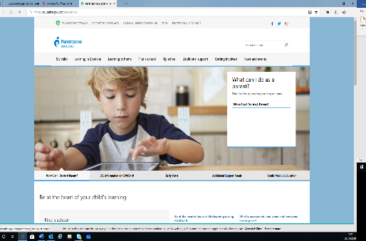

Some other tips to encourage your child to talk about their learning.
- Choose the right time to talk – a relaxed atmosphere is good
- Choose the right place to talk – away from technology if possible for both parents and children!
- Make/plan time to talk
- Try to ask open questions – avoid ‘yes’ or ‘no’ answers!
- Avoid the ‘interrogation’ scenario
- Support and praise.
- Make sure to listen to what they are saying or answering

The Sculptor
I dreamed I stood in a studio,
And watched two sculptors there.
The clay they used was a young child’s mind
And they fashioned it with care.
One was a teacher;
The tools he used were books, music and art.
One a parent:
With a guiding hand and a loving gentle heart.
Day after day the teacher toiled
With a touch that was loving and sure;
While the parent laboured by his side
And polished and smoothed it o’er.
And when at last their work was done,
They were proud of what they had wrought,
For the things they had moulded into the child
Could neither be sold or bought.
And each agreed he would have failed,
If he had worked alone,
For behind the parent stood the school,
And behind the teacher,
The home

Monymusk School

Finding Out More About My Child’s Progress in Learning.
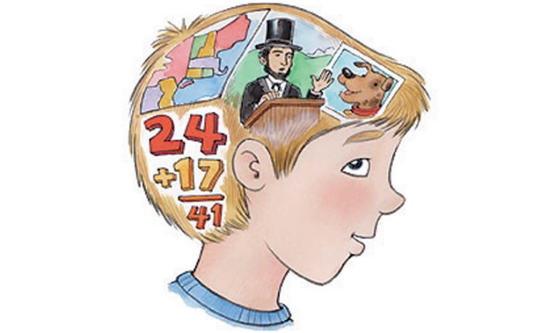

Your Child is like a living report!

In school, we help your children to understand their learning in order to know how well they are doing. This enables them to talk about it in an informed way.

They, in turn, can help you to understand about their learning and talk to you about how well they are doing.

We hope this leaflet helps you to find out more about their progress in learning.

